SWE K-12 Outreach – Links You Can Use

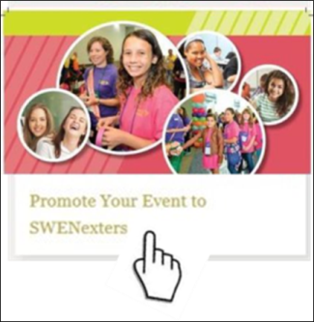
Report your Outreach events on the Outreach Metric Tool at:
https://www.surveymonkey.com/r/SWEOMTFY18

SWENext

Promote your outreach event to SWENexters in your area:
http://societyofwomenengineers.swe.org/page/5147-swenext-events

Download SWENext flyers, promotional materials, and logos at outreach events:
http://societyofwomenengineers.swe.org/page/4584

Learn about SWENext Clubs at: http://societyofwomenengineers.swe.org/page/4722-swenext-club

Find a SWENext Club near you:
https://www.google.com/maps/d/u/0/viewer?mid=1Bc9ipByNusbaJIkeEbJgq1V6VHU&ll=29.236450729177598%2C-57.497222400000055&z=3

Collegiate Sections: Participate in the SWENext Video Challenge to tell SWENexters all about your school in under 3 minutes: https://app.smarterselect.com/programs/42162-Society-Of-Women-Engineers

K-12 Educator Membership

Learn more (including flyers to share with educators in your area):
http://societyofwomenengineers.swe.org/k-12-educator-membership

General K-12 STEM Outreach Resources

Join the SWE Outreach Incubator Facebook Group at:
https://www.facebook.com/groups/223715534629778/?ref=bookmarks

Find the K-12 Outreach Tool Kit at:
http://societyofwomenengineers.swe.org/page/4768-Outreach-Toolkit

Learn about the latest Wow! Innovation Challenge at:
http://societyofwomenengineers.swe.org/page/4674-welcome-to-the-wow-innovation-challenge-page

Learn how to apply for a Program Development Grant for your Outreach program at:
http://societyofwomenengineers.swe.org/program-development-grants

Get presentations and handouts for your Parents and Educator Program (PEP) track by emailing maryzeis@gmail.com (PEP Tool Kit coming soon!)

Get the Assessment Made Easy step-by-step survey creation tool at:
http://societyofwomenengineers.swe.org/swe-members/479-slides/4159-assessment

If you ever need K-12 Outreach information that you can’t find, send an email to the current SWE Outreach chair at: outreach-chair@swe.org or to your Region G STEM Outreach Rep at: maryzeis@gmail.com.

